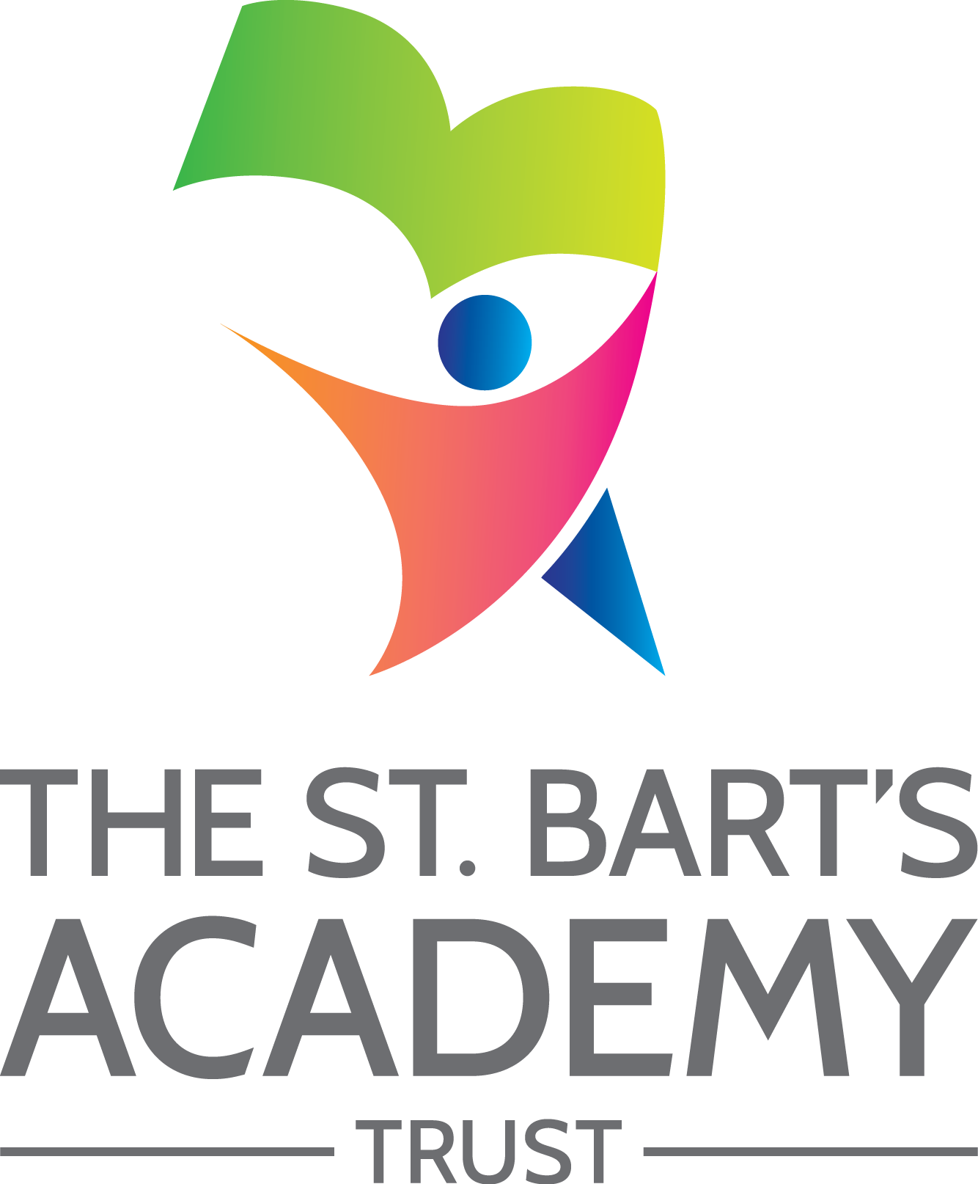

Choose an item.

**Accessibility**

**Plan**

**September 2023**

|  |  |  |
| --- | --- | --- |
| **The St. Bart’s Academy Trust** | | |
| Accessibility Plan | | |
|  | | |
| **Date** | **Section Amended** | **Signature** |
| 01/03/2023 | TSB Policy Adopted – v4 | S. Jones |
|  |  |  |
|  |  |  |
|  |  |  |
|  |  |  |
|  |  |  |
|  | | |



Contents

Statement of intent 4

1. Accessibility Plan - *Insert relevant year e.g. 2022-2023* 5

2. Planning Duty 1: Curriculum 6

3. Planning Duty 2: Physical Environment 7

4. Planning Duty 3: Information 8

Statement of intent

This plan outlines how **Park Hall Academy** aims to increase access to education for pupils with disabilities in the three areas required by the planning duties in the Equality Act 2010 (i.e. the curriculum, physical environment and information).

A person is regarded as having a disability under the Equality Act where they have a physical or mental impairment that has a substantial and long-term adverse effect on their ability to carry out normal day-to-day activities.

This plan aims to:

* Increase the extent to which pupils with disabilities can participate in the curriculum.
* Improve the physical environment of the school to enable pupils with disabilities to take better advantage of education, benefits, facilities and services provided.
* Improve the availability of accessible information to pupils with disabilities.

The above aims will be delivered within a reasonable timeframe, and in ways which are determined after taking into account pupils’ disabilities and the views of parents and pupils. In the preparation of an accessibility strategy, the LA will have regard to the need to allocate adequate resources in the implementation of this strategy.

The governing committee also recognises its responsibilities towards employees with disabilities and will:

* Monitor recruitment procedures to ensure that individuals with disabilities are provided with equal opportunities.
* Provide appropriate support and provision for employees with disabilities to ensure that they can carry out their work effectively without barriers.
* Undertake reasonable adjustments to enable staff to access the workplace.
* The plan will be resourced, implemented, reviewed and revised in consultation with:
* Pupils’ parents.
* The principal and other relevant members of staff.
* Governors.
* External partners.

1. Accessibility Plan – *2024 - 2025*

Our Accessibility Plan sets out how this Academy will improve equality of opportunity for disabled people. This plan sets out the establishment’s proposals to increase access to education for disabled pupils in the following three areas:

* Increasing the extent to which disabled pupils can participate in the curriculum on an equal basis with their peers;
* Improving the physical environment of the establishment to enable disabled pupils to take better advantage of education and associated facilities and services; and
* Improving the availability of accessible information to disabled pupils.

The preparation of the Accessibility Plan has been informed by audits and analyses of data within the Academy and its premises. It is a requirement that the Accessibility Plan is resourced, implemented and reviewed as necessary and at least annually. A copy of this Plan together with the SBMAT Accessibility Policy will be placed upon our website.

This plan will be reviewed on an annual basis by the Local Governing Committee and Principal. Any changes to this plan will be communicated to all staff members and relevant stakeholders.

1. Planning Duty 1: Curriculum

|  |  |  |  |  |
| --- | --- | --- | --- | --- |
| **Issue / Action** | **Lead Responsible** | **Identified Budget**  **and any other resources** | **Target Date** | **Success Criteria** |
| Monitor curriculum to ensure that high quality learning for all pupils is provided by skilled and knowledgeable staff. | SLT | Monitoring: Showbie looks, learning looks, learning walks, pupil interviews. | Termly monitoring | High quality, learning and teaching is provided to all pupils ensuring the progress and achievement for all pupil groups. |
| Challenge and support meets the diverse needs of all learners. | SLT/ SENCO | Monitoring: Showbie looks, learning looks, learning walks, pupil interviews.  SEND monitoring, SEND pupil voice. | Termly monitoring | Mastery, small step approach to learning.  Cooperative learning/ Kagan groups used to support & extend learners.  Showbie support materials independently accessed by pupils to aid independent learning.  Effective feedback provides pupils with models and worked examples to independently, correct errors.  Scaffolding e.g. through the use of worked examples (teacher videos/ voice notes) stem sentences, expert pupils. |
| Individual pupil needs are met to allow them to access the full curriculum. | SLT/ SENCO | Monitoring: Showbie looks, learning looks, learning walks, pupil interviews.  SEND monitoring, SEND pupil voice. | Termly monitoring | Range of techniques & strategies used to support individual needs and styles.  Access to concrete resources to support learning e.g. manipulatives/ maths toolkits  Multi-sensory approaches to learning for pupils e.g. rainbow writing.  Makaton, PECS, visual timetables are used by individual pupils to support their needs.  External, multi-agency support is sought to support individual pupil needs and remove potential barriers to learning. |
| Raise attainment through the use of creative & innovative use of technology | All staff | Monitoring: Showbie looks, learning looks, learning walks, pupil interviews.  SEND monitoring, SEND pupil voice. | Termly monitoring | Use of 1:1 iPads enables pupils individual access to their learning and promotes independence.  Innovative use of technology to enable learners to be immersed in learning, exposing pupils to experiences beyond what they may have experienced e.g. augmented reality, virtual museum tours, walking with dinosaurs. |
| Supporting pupils, social, emotional & mental health development. | All staff/ SLT | Pupil interviews/ voice, Passport targets for individuals. EP support. | Monitoring of pupil’s emotional checks to monitor impact.  Pupil interviews to understand impact of strategies on mental health development. | High quality learning of essential skills and concepts to support pupils in developing and building a resilient, and happy mind.  Individual support for pupils with additional emotional & mental health needs e.g. positive behaviour plans to raise self-esteem and improve behaviours for learning, meet & greet sessions, emotional rating scales, what went well. |
|  |  |  |  |  |

1. Planning Duty 2: Physical Environment

|  |  |  |  |  |
| --- | --- | --- | --- | --- |
| **Issue / Action** | **Lead Responsible** | **Identified Budget**  **and any other resources** | **Target Date** | **Success Criteria** |
| Classroom organisation meets the needs of pupils. | SLT | Flick Learning | Termly | Tidy clutter free environments ensure pupil access to the environment and equipment.  Organised classroom libraries enables independent access to reading materials.  Maths toolkits allow independent access to concrete resources. |
| Incorporate accessibility into any proposed structural alternatives | SLT/ planning team | Proposed building budget | TBC | Advice sought before commencement of planned building work to the environment to ensure accessibility for all. |
| Accessibility to the school environment | SLT | No identified adjustments required at present. | - | Some classrooms within the school are inaccessible to pupils with mobility difficulties due to the school accommodation being over three floors. Reasonable adjustments are made (considered at all transition points to ensure best use of school accommodation).  Low handrails, alongside regulation height handrails, are on all staircases. |

1. Planning Duty 3: Information

|  |  |  |  |  |
| --- | --- | --- | --- | --- |
| **Issue / Action** | **Lead Responsible** | **Identified Budget**  **and any other resources** | **Target Date** | **Success Criteria** |
| iPad technology enables all learners to access information in formats that best suit all individual needs. | SLT/ SENCO | iPad budget | Autumn 2023 – with updates/ refreshers throughout the year during staff meetings. | Use of a range of accessibility tools on the iPad readily available to all pupils and adults e.g. magnifier, colour, overlay, read aloud etc.  Staff CPD ensures all adults are aware of the features of the iPad and its functions and benefits for all pupils when using the accessibility tools.  Pupils independently access accessibility features on their iPad meeting their individual needs, e.g. coloured overlay filters, speech/dictation tool, magnify tool. |
| Effective feedback to learners through the use of technology, promotes progress and attainment for all. | SLT/ SENCO | Monitoring cycle – pupil voice, Showbie looks | Monitoring cycle. | Voice note tool used by staff to provide effective feedback to pupils, enabling them to correct mistakes and move forward with their learning.  Pupils use voice notes/ videos to enable staff to ‘hear pupil thinking’ demonstrating their progress following feedback. |
| Use of a range method to communicate with the Park Hall family to ensure access to information for all. | SLT | iPad technology, Showbie, class dojo. | Ongoing | Class dojo learning videos share individual pupil learning/ support materials.  Forms used to inform/ gather information from parents with accessibility features of ‘read aloud’, choice of language, instant return of answers.  Information videos regularly shared to inform parents of important information via class dojo/ social media page. |



St. Bart’s Multi-Academy Trust

c/o Belgrave St. Bartholomew’s Academy,

Sussex Place, Longton, Stoke-on-Trent, Staffordshire, ST3 4TP

www.sbmat.org T: 01782 486350