PE Funding

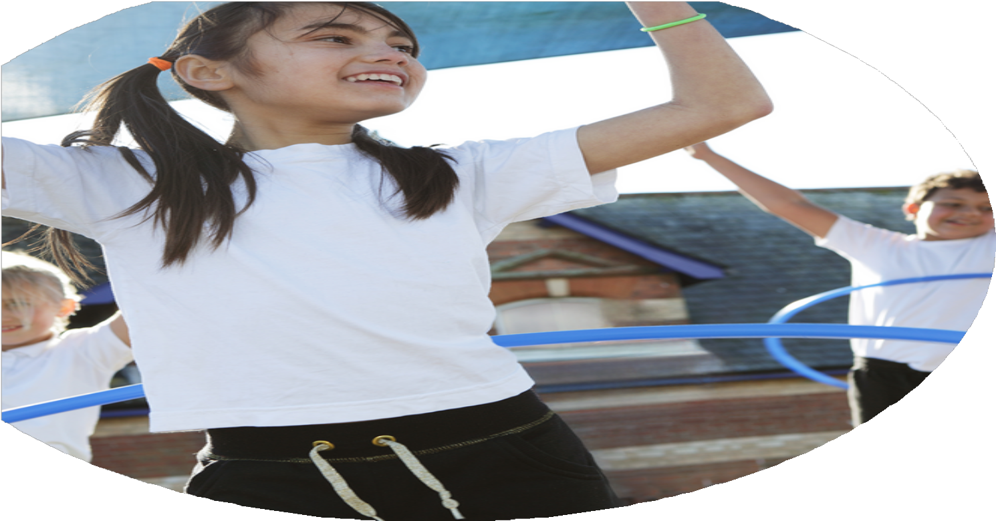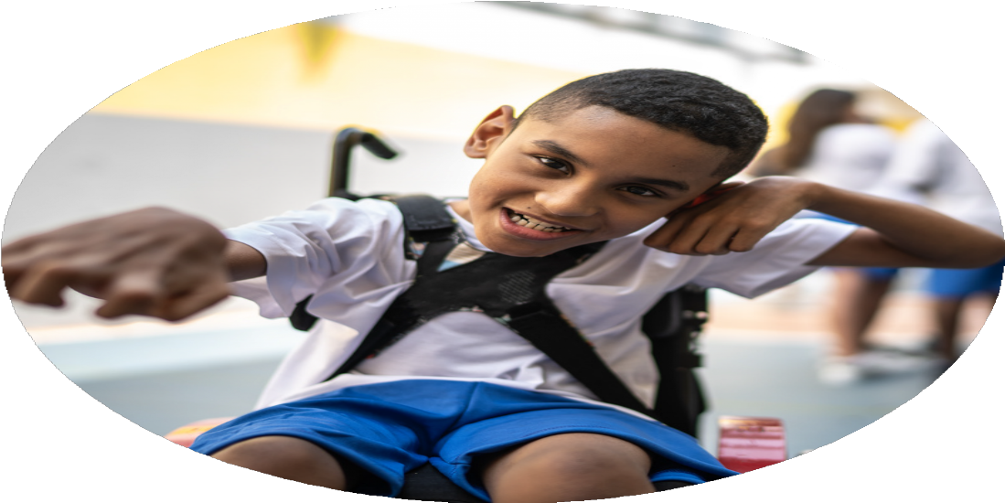

Evaluation Form

**Commissioned by**

**Created by**

Images courtesy of Youth Sport Trust

**PE Funding Evaluation Form**

 It is intended that this template should be used as preparation for the completion of the statutory digital reporting tool being introduced this academic year. You can upload data (including swimming) from this template onto this platform once it becomes accessible.

 Before you decide how you are going to use the funding for this academic year you should reflect and evaluate the impact of your use of the funding in 2023/24.

 All spending of the funding must conform with the terms outlined in the Conditions of Grant document.  The template is a working document that you can amend/update during the year.

 Based on your evaluation of last year’s funding you should decide what you intend to do this academic year, how you will do it, and what impact you expect it to have.

It is important that the funding is used effectively and based on your school’s needs.

 You must use the funding to make additional and sustainable improvements to the PE and sport in your school.  You must develop and add to the PESSPA activities that your school already offers.

*Summative digital reporting from June 2025 will continue to include swimming and water safety information therefore funding can be used to provide top-up lessons where necessary to ensure pupils meet national curriculum swimming requirements.*

* Achievement of the Platinum Sports Award – with a focus on engagement of girls in sport. Case study with parent reviews and pupil experience.
* Feedback from staff and lesson looks demonstrated that teachers felt more confident in the teaching of the skills and were able to utilise this knowledge to develop all learners knowledge and skills.
* Increase in sporting accolades and GDS pupils been selected from higher level sports.
* Whole school approach to sport and the parent testimonies supported the impact of games calendar and competitive sport.
* More girls engaged in competitive sport.
* Staff gaining in knowledge and skills in gymnastics
* Excellent return in competitive fixtures and results that has expanded from the gold standard curriculum.
* Sporting extra-curricular activities – Football, Tag-Rugby, Cross Country, Netball, Athletics
* Implementation of sport leaders organizing and running sporting activities at dinner times. To utilise the 30-60 minutes of physical activity each day.
* All pupils have the opportunity to experience competitive sport through the school games calendar and lessons.
* Working alongside Chance To Shine Cricket and County level competitions.

What are your plans for 2024/25?

Intent

How are you going to action and achieve these plans?

Implementation

1. CPD for subject lead to attend 2 day dance course – Taking Dance to the Next Level which is then disseminated to staff, followed by lesson looks etc.
2. Forest School training – with the Forest School association.
3. Expose our pupils to even more extra-curricular activities. This will be moving the timings of clubs to a morning club to start their school day with a morning run (cross country club).
4. Ensure pupils who are the least active experience the school games calendar at every given opportunity.
5. CPD for teachers – dance, Tennis. (Focus areas of the curriculum).
6. Forest Schools – To embed this
7. Continue to add to the provision of extra-curricular activities including: Tag-Rugby, Cricket, morning Cross Country clubs.
8. Further SEN pupils given opportunities to engage in the school games calendar. (Sport4all, Change of life festival)

What impact/intended impact/sustainability are you

expecting?

How will you know? What **evidence** do you have or

expect to have?

1. This will be demonstrated through lesson looks/ pupil voice interviews with pupils making progress which will be demonstrated through PE passport.
2. Establishes pupils to be given a voice on their PE journey. Enables pupils to deliver active playtimes alongside staff members. Targeted activities given to the children that link to curricular areas.
3. Pupils uptake will increase to cater all pupils to fulfil their sporting ambitions. Pupils will be engaged in non-traditional sports that will appeal to pupils who are less interested in the convention. This will also create a pathway into higher education PE that our pupils will access after Year 6.
4. Phot and Video evidence collected from PE passport, competitive events and data collected from assessment tool.
5. Dissemination of the training to all staff to enable high quality learning and teaching. Through the delivery of the skills to all staff this is creating a sustainable level of education for teachers.
6. Experienced Sport Leaders
7. Diverse Sport Offerings.
8. Inter/Intra curricular opportunities for all pupils

What **impact/sustainability** have you seen?

What **evidence** do you have?

1. Sports leaders are developing their own sporting leadership and organisation skills while running activities.
2. Real Life Park Hall Heroes. Sporting Heroes that are in the Park Hall Family. That fulfil a pathway for our pupils to aspire to be the best version of themselves.