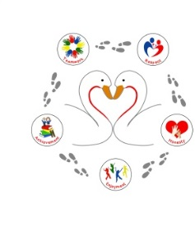
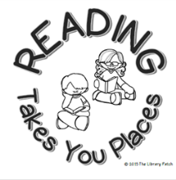
MUST reads whilst you’re in Year 1 and Year 2

Are you up for the challenge? Tick off the books as you read them. How many will you read?
Spot Bakes a Cake - Eric Hill |  | Shark in the Park - Nick Sherratt |  | Never Say no to a Princess! -Tracey Corderoy and Kate Leake
Old Bear - Jane Hissey |  | Supertato - Sue Hendra |  | Meerkat mail - Emily Gravett
Peepo - Janet and Allan Ahlberg |  | The Animal Boogie - Debbie Harter |  | The Tunnel - Anthony Browne
Bizzy Bear - Fun on the Farm - Benji Davies |  | The Jolly Postman - Janet and Allan Ahlberg |  | Funnybones - Janet and Allan Ahlberg
Monkey and Me - Emily Gravett |  | Dogger - Shirley Hughes |  | The Cat in the Hat - Dr. Seuss
That's not my car - Fiona Watt |  | Little Rabbit Foo Foo - Michael Rosen and Arthur Robins |  | Where the Wild Things Are - Maurice Sendak
Where's Spot? - Eric Hill |  | Polar bear, polar bear what do you hear? - Eric Carle |  | The Great Paper Caper - Oliver Jeffers
Brown Bear, Brown Bear what do you see? - Bill Martin Jr. and Eric Carle |  | Don't put your finger in the jelly, Nelly! - Nick SherratT |  | The Owl who was afraid of the dark - Jill Tomlinson and Paul Howard
Silly Suzy Goose - Petr Horacek |  | Giraffes Can't Dance - Giles Andreae and Guy Parker-Rees |  | The Tale of Peter Rabbit - Beatrix Potter
Dinosaur Roar! - Paul Stickland and Henrietta Stickland |  | The Day the Crayons Quit - Drew Daywalt and Oliver Jeffers |  | Hairy McClary from Donaldson's Dairy - Lynley Dodd
A Bear Called Paddington |  | My Dad’s got an alligator by Jeremy Strong |  | Here come the aliens Colin McNaughton

