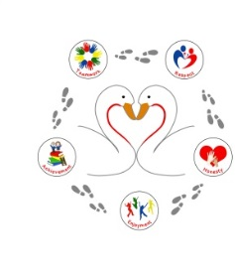
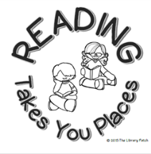
MUST reads whilst you’re in Year 3 and Year 4

Are you up for the challenge? Tick off the books as you read them. How many will you read?
Flour Babies by Anne Fine |  | The BFG by Roald Dahl |  | Revolting Rhymes by Roald Dahl
Fantastic Mr Fox by Roald Dahl |  | Charlotte’s Web by E.B. White |  | The Parent Agency By David Baddiel
The Folk of The Faraway Tree by Enid Blyton |  | Railway Children |  | Percy Jackson and the Lightning Thief by Rick Riordan
Matilda by Roald Dahl |  | The Diary of a Killer Cat by Anne Fine |  | The Amazing story of Adolphus Tips by Michael Morpurgo
Flat Stanley by Jeff Brown |  | The Iron Man by Ted Hughes |  | The Jungle Book by Rudyard Kipling
The Magic Finger by Roald Dahl |  | The Witches by Roald Dahl |  | Wind in the Willows
You’re a Bad Man, Mr Gum! By Andy Stanton and David Tazzyman |  | Worst Witch by Jill Murphy |  | Clever Polly and the stupid Wolf by Marjorie-Ann and Catherine Storr
The Story of Tracey Beaker by Jacqueline Wilson |  | Sheep Pig by Dick King Smith |  | The Secret Garden by Frances Burnett
Horrid Henry by Francesca Simon |  | Black Beauty |  | How to Train Your Dragon by Cressida Cowell
Diary of a Wimpy Kid by Jeff Kinney |  | Billionaire Boy by David Walliams |  | Little women
A Book of Nonsense by Edward Lear |  | Mr Stink by David Walliams |  | White Fang
Charlie and the Chocolate Factory by Roald Dahl |  | The Secret Garden by Frances Hodgson Burnett |  | Wuthering Heights
Collect your sticker for reading 36 books
Collect your sticker for reading 24 books
Collect your sticker for reading 12 books

