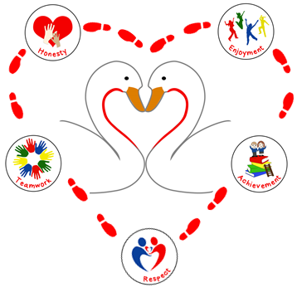

Continuing The Learning Journey Together

Social Media Policy.

**Date: January 2019**

**Review: January 2020**

Social Media Policy



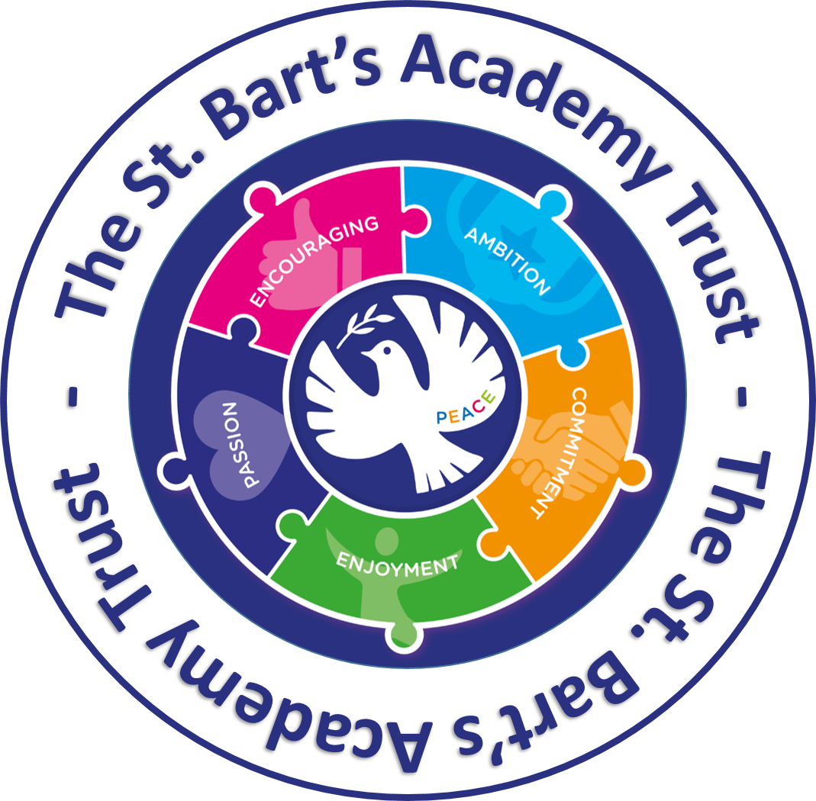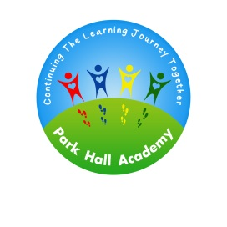



Introduction.

The widespread availability and use of social networking applications bring opportunities to understand, engage and communicate with our audiences in new and exciting ways. It is important that we are able to use these technologies and services effectively and flexibly. However, it is also important to ensure that we balance this with our duties to our community and partners, our legal responsibilities and our reputation.

The academy recognises the numerous benefits and opportunities which a social media presence offers. Staff, parents/carers and pupils (under direct supervision as part of the curriculum) are actively encouraged to find creative ways to use social media. However, there are some risks associated with social media use, especially around the issues of safeguarding, bullying and personal reputation.

This policy aims to encourage the safe use of social media by the school, its staff, parents, carers and children and should be read in conjunction with the E-Safety Policy, Computing Policy, Anti-Bullying, Prevent and The Staff and *Parents and Pupils Acceptable Use Policy*.

The policy requirements in this document aim to provide this balance, to support innovation and Schools of the 21st Century, whilst providing a framework of good practice. This protocol recognises the guidance set out in the document ‘Guidance for Safer Working Practice for Adults who work with Children and Young People in Education Settings’ (DCSF January 2009).

This policy applies to Employees, Governors and third parties working within our school. These groups shall be referred to as “School Representatives” for the purpose of this policy.

Aims and Objectives.

* Set clear expectations of behaviour and/or codes of practice relevant to social networking for educational,

personal or recreational use

* Support safer working practices
* Assist staff working with children to work safely and responsibly with the internet and other communication technologies and to monitor their own standards and practice
* Give a clear message that unlawful or unsafe behaviour is unacceptable and that, where appropriate, disciplinary or legal action will be taken
* Ensure that the academy and its leaders and governors are not exposed to legal risks
* To use social media to positively promote and communicate our pupils engaging learning journey.
* To work in partnership with all members of the Park Hall family, including staff, parents/carers and governors, to ensure that we all model the values we expect our children to demonstrate in their online communications.
* To be an agent of change, promoting positive and respectful online communications.

‘Create, connect and share respect a better internet starts with you’

What is social media?

Social Media Policy Social media (e.g. Facebook, Twitter, Snapchat) is a broad term for any kind of online platform which enables people to directly interact with each other. However some games, for example Minecraft or Fortnite and video sharing platforms such as You Tube have social media elements to them.

There are four key aspects in our social media policy. These are:

* The use of social networking sites by pupils within and beyond the academy.
* Use of personal social networking by employees/volunteers.
* Positive partnerships with parents/carers.
* Responding to non-compliance with the Social Networking Policy.

**The use of social networking sites by pupils within and beyond the academy.**

We understand the importance of educating pupils in the responsible use of social media. Our values are at the heart of everything that we do, respect is one of our core values which is the golden thread under-pinning all aspects of our work. Children recognise the importance of showing respect when they connect with other users online. Our E-Safety Mascot, Terrific Tom teaches our children to:

**‘Tweet other’s as you would like to be tweeted’.**

The school's *Parents and Pupils Acceptable Use Policy*, outlines the expectations for using technology in our academy and these expectations therefore apply to use of social networking sites. Such sites should not be used/accessed in our academy by pupils, unless under the direction of a teacher and for a purpose clearly apparent from the learning objective of the relevant learning experience. If social media sites are used, then staff will carefully select appropriate content. Parents give permission for children to access these sites in our academy as well as permission for images of their child/ child’s work to be included on the academy’s social media sites. (See social Media consent form).

Parents/Carers and pupils are aware that social networking sites have age restrictions and that these should be adhered to.

Pupils are not allowed access to mobile phones in our academy.

**Use of personal social networking by employees/ volunteers.**

All adults working with pupils have a responsibility to maintain public confidence in their ability to safeguard the welfare and best interests of pupils.

The pupils, parents, colleagues and school governors are entitled to expect the highest standards of conduct from all employees who work in our academy. It is therefore expected that staff will adopt high standards of personal conduct in order to maintain the confidence and respect of their colleagues, pupils, public in general and all those with whom they work in line with the school’s code of conduct. Adults in contact with pupils, should therefore understand and be aware that safe practice also involves using judgement and integrity about behaviours in places other than the work setting.

School staff should always maintain appropriate professional boundaries and avoid behaviour, during their use of the internet and other communication technologies, which might be misinterpreted by others. They should report and record any incident with this potential

All employees agree to adhere to the *Staff and Volunteer Acceptable Use Policy.*

**Positive partnerships with parents/carers.**

We expect parents and carers to work in partnership with the academy to protect all members of the Park Hall family. We further expect, parents and carers to model the values that we expect our children to demonstrate by showing respect and consideration for all members of the Park Hall family. Parents/Carers/family members must not post images of pupils, other than their own children (parents should ensure that no other children can be seen in the background) on social media sites where these images have been taken at school events.

We are proactive in supporting parents and carers to enable them to protect and support their child in their online communications. The academy newsletter, social media accounts, website and workshops all educate and update parents and carers and provide useful links to resources and guides to assist parents in protecting their child.

Parents and carers, are strongly advised to directly supervise their child when they are using the Internet outside of school in order to ensure that children consistently demonstrate safe and respectful practises online.

Parents and carers are made aware of the academy expectations through the, *Parents and Pupils Acceptable Use Policy – Academy Information systems, E-safety and Social* *Media Code of Conduct*, (this must be signed before pupils are granted Internet access).

We aim to work in partnership with all members of our Park Hall family and expect all members of our family to demonstrate mutual respect and ensure that all online communications are respectful.

Parents must not post derogatory comments about the academy or any members of the Park Hall family online. We pride ourselves in our partnerships with parents and will always endeavour to maintain positive relationships with all family members. Where a parent/carer has any concern or grievance, they must address these with their child’s class teacher in the first instance. Should a concern remain unresolved at this point, parents/carers should contact the Phase Leader.

**Responding to non-compliance with the Social Networking Policy.**

The guidance contained in this policy is an attempt to identify the behaviours we expect of staff, volunteers, pupils, parents/carers and governors.

The academy will take appropriate action in the event of breaches of the social media policy. Where conduct is found to be unacceptable, the academy will deal with the matter internally. Should conduct be considered illegal, the academy will report the matter to the police and other relevant external agencies, and may take action according to the disciplinary policy.

In the case of inappropriate use of social media by parents/carers, the Local Governing Body will contact the parent/carer directing them to remove such comments and ensure that a parents complaint/grievance is dealt with through the academy complaints policy.

The Local Governing Body understands that, “There are circumstances in which police involvement is appropriate. These include where postings have a racist element or where violence is threatened or encouraged.” Furthermore, “Laws of defamation and privacy still apply to online communications and it is unlawful for statements to be written which:

* expose (an individual) to hatred, ridicule or contempt
* cause (an individual) to be excluded or avoided
* lower (an individual’s) standing in the estimation of others
* ridicule (an individual in their) business, trade, office or profession.”

Policy Review.

* Our Social Media Policy has been written in collaboration with the Children’s Safeguarding Board, Computing and E-Safety Leader, Computing and E-Safety Governor and the Principal with reference to ‘Guidance for Safer Working Practice for Adults who work with Children and Young People in Education Settings’ (DCSF January 2009).
* The Social Media Policy and its implementation will be reviewed annually.

Signed: G Frost

Date: January 2019

Review Date: January 2020