

We are delighted that so many of you have joined our Park Hall Academy SBMAT Facebook page. It is a great space to be able to communicate with our parents/ carers and receive comments and questions which other parents and school staff are able to respond to.
On the 17th May, we will be holding our Summer Fun Day and Fayre. We would love to have more parents/carers join our Park Hall Family (PTFA) group to help out and give suggestions. If you would be able to contribute in any way, please comment on the Facebook page, with a suggestion of the day/ time that would be most convenient for you to meet as a group to plan the day. Thank you.


Making a difference!
We have signed up to be a part of ‘The Big Battery Hunt,’
to do our part in helping to make a difference to the
environment.
Please fill the box with batteries, marking on the tally (on
the side of the box) as you go.
Park Hall Parliament members will keep a tally of their
classes contributions. The class which collects the most
batteries will receive a ‘green award’ certificate for their
efforts.

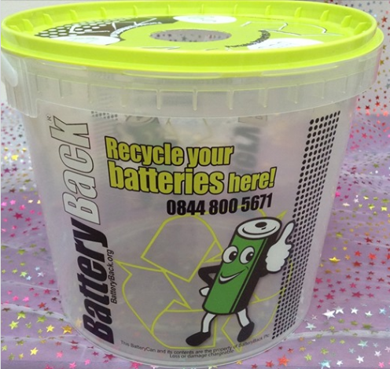


We look forward to seeing you at the assertive mentor meetings next week where class teachers will be sharing your child’s progress and attainment.
Key Stage 1 pupils are now undertaking their NCT’s (SATs) and Year 6 pupils NCT’s will begin on 13th – 16th May.
Please ensure that children attend school every day and bring with them a water bottle each day.
We are really proud of the growth mindset that all children are displaying!




Carnival of Colour – if you would like to contribute to our Carnival of Colour display, we would really appreciate donations of the children’s masks. They will make a wonderful addition to our colourful displays around school. Thank you.



Learning and Teaching.
Learning and Teaching.
Learning and Teaching.
Footprints – please reserve your place for May half term by the 17th May. There are many exciting activities and trips to take part in!
Continuing the Learning Journey Together.

