


Wind in the Willows
What an amazing show and experience! The children loved watching
the story brought to life before their eyes. It was an action packed
adventure with music and singing throughout.
Children are busy now producing their ‘Star Writing’ based on the story.
Many of the children’s favourite character was Mr. Toad.
Georgia in 2A described Mr. Toad in her recount-
‘I wonder why Mr. Toad loves patterns on his clothes. He wears a beautiful, black bow tie. I love his brown, laced shoes. Mr. Toad is hilarious because
he always makes people laugh. I think he loves adventures
and so he is adventurous! Mr Toad is my favourite character.
He improves himself so much!’
Rose from 2N says about Mr Toad,
‘Mr Toad presents himself as a posh, fancy and rich toad because he lives in a 32 bedroom huge mansion. Mr Toad has a greeny, mint and lime outfit. Mr Toad has stripy, brown and patterned socks!’

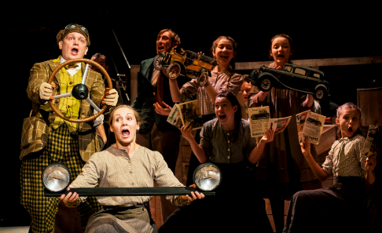

Key Stage 1 Valentines Party – Monday 11th February. 3.30 p.m. – 5.00 p.m.
Children in years 1 and 2 are invited along straight after school to take part in fun and games at the Valentines Party. We will be playing games such as Valentine Bingo, Heart Hop and Who’s Cupid as well as dancing and snacks. School uniform will be worn at the event – no need to bring party clothes.
Ticket price is £3.50 which includes a goodie bag containing valentine snacks and a drink and so no more money will be needed at the event. If you would like you child to attend, please complete the reply slip on the last page and return to your child’s class teacher with payment by Wednesday 6th February.

Key Stage 2 – Valentines Disco - Wednesday 13th February. Children no longer need to pay in advance for a ticket. At the event children can pay on the door and will only be released afterwards to a responsible adult.




‘Back to School’
Families were sent ‘back to school’ this week in Year 2 and 6 when they attended maths workshops. Thank you to everyone who was able to attend as we understand that we have many working parents who cannot attend all events.
The wonderful gold book comments demonstrate the value of these events in helping parents/ carers to support their children’s learning journey at home. Remember, with an admirable attitude #mathseveryonecan!


Continuing the Learning Journey Together.
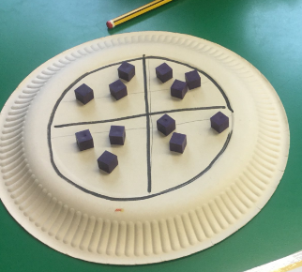
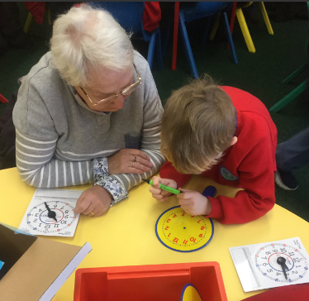
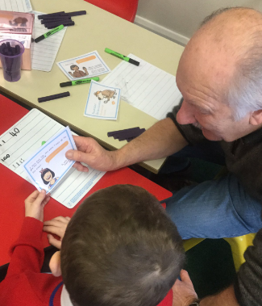


Learning and Teaching.
Learning and Teaching.
Learning and Teaching.


Book Amnesty

Please can you check at home for any reading books which your child may
have that they are no longer reading as not all books are being returned to
school. This of course then impacts upon the number of books that we
have for children to choose from. Thank you.

Gritting Policy
In the event of icy conditions, the main pathway into school and around the school will be gritted by Mr Oldham, our site supervisor.
In the event of extreme conditions/ heavy snow – a path will be cleared from the main gate to the key stage 1 entrance double doors. All pupils will enter the school this way.

If you bring your child to Footprints before and after school by car, please ensure to park by the rainbow fencing and not on the staff carpark. There is limited parking available for staff. This also ensures that children do not have to walk with parents across the carpark.


Well done to 2A, Miss Adams class, for their wonderful assembly all about penguins.
The assembly was filled with facts about the wonderful creatures and also about simple everyday things we can all do will help to protect their environment such as switching off electrical appliances at the socket and not leaving the
tap running when we brush our teeth!

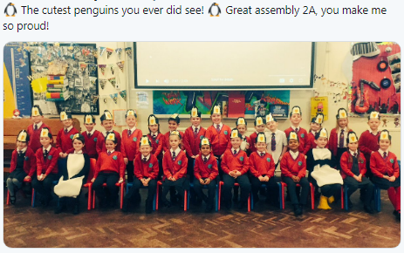
Upcoming diary dates
5th February 2019 | E-Safety Day – separate letter to follow
7th February 2019 – 9.05 a.m. | Year 6 ‘Back to School’ GRASP Family Fun
Monday 18th Feb – Friday 22nd Feb 2019 | Half term
Monday 25th February | Return to school - Spring Term begins.
Key Stage 1 Valentines Party
I would like my child _____________________________________________
in class_______________________________ to attend the Valentines Party after school on Monday 11th February.
I will collect my child from the hall doors at 5.00p.m.
Signed ___________________________________________________________
Date _____________________________________

