PP Park Hall Academy 2019/ 2020
Evidencing the Impact of the Primary PE and Sport Premium.

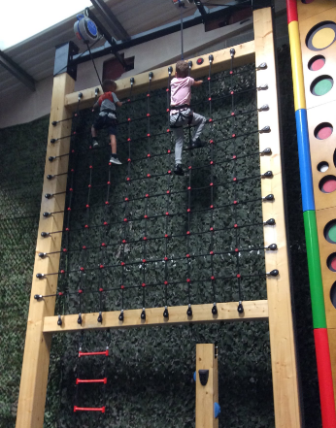

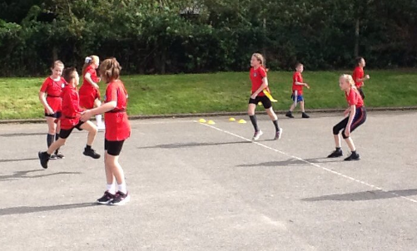
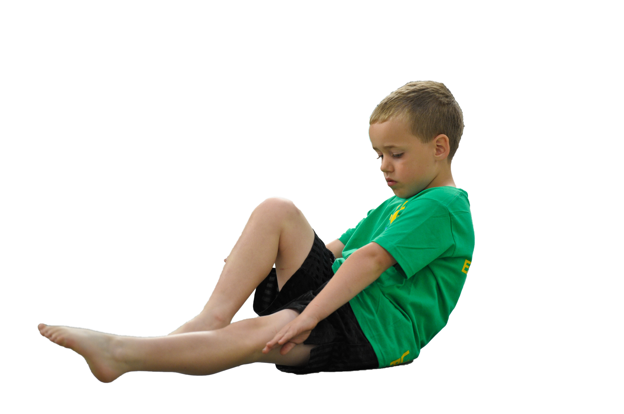
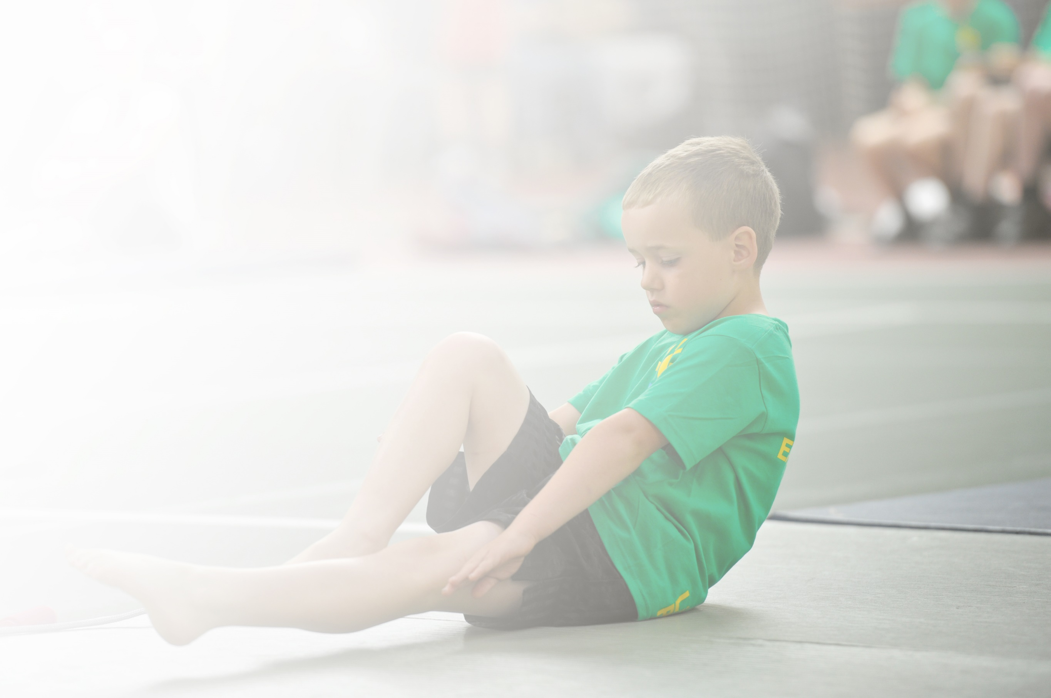
Schools must use the funding to make additional and sustainable improvements to the quality of Physical Education, Sport and Physical Activity (PESPA) they offer. This means that you should use the Primary PE and Sport Premium to:

- Develop or add to the PESPA activities that your school already offer
- Build capacity and capability within the school to ensure that improvements made now will benefit pupils joining the school in future years

Please visit gov.uk for the revised DfE guidance including the 5 key indicators across which schools should demonstrate an improvement. This document will help you to review your provision and to report
your spend. DfE encourages schools to use this template as an effective way of meeting the reporting requirements of the Primary PE and Sport Premium.

We recommend you start by reflecting on the impact of current provision and reviewing the previous
spend. Under the Ofsted Schools Inspection Framework, inspectors will assess how effectively leaders use the Primary PE and Sport Premium and measure its impact on outcomes for pupils, and how effectively governors hold them to account for this.

Schools are required to publish details of how they spend this funding as well as on the impact it has on pupils’ PE and sport participation and attainment by the end of the summer term or by 31 July 2019 at the
latest.
We recommend regularly updating the table and publishing it
on your website throughout the year, as evidence of your
ongoing review into how you are using the money to
secure maximum, sustainable impact. To see an
example of how to complete the table please
click HERE.

Support for review and reflection - considering the 5 key indicators from DfE, what development needs are a priority for your setting and your students now and why? Use the space below to reflect on previous spend, identify current need and priorities for the future.

Key achievements to date: | Areas for further improvement and baseline evidence of need:
- Children continued to remain engaged with physical activity during the Spring and Summer terms remotely. The school received two awards (School Games Mark) due to the number of pupils engaged.  - Installation of new sports arena – astro turfed large area containing daily mile, sport/ games markings and multi-gym equipment.  - Continuing to work towards Platinum Quality Mark for Pe and Sport | - Further develop pupil’s leadership qualities as Sports Ambassadors and Play Leaders so that they can then encourage and involve children to take part in organised sports activities during the school day.  - Further opportunities for all teaching staff to receive CPD/ team teaching by working alongside our Sports Coach to develop and embed subject knowledge.  - Organise termly ‘inter house’ and ‘intra house’ sports competition.  - Achievement of the Platinum Quality Mark for PE and Sport.

Meeting national curriculum requirements for swimming and water safety | Please complete all of the below:
What percentage of your current Year 6 cohort swim competently, confidently and proficiently over a distance of at least 25 metres?  N.B. Even though your children may swim in another year please report on their attainment on leaving  primary school. | 83.3%
What percentage of your current Year 6 cohort use a range of strokes effectively [for example, front crawl, backstroke and breaststroke]? | 78.3%
What percentage of your current Year 6 cohort perform safe self-rescue in different water-based situations? | 41.7%
Schools can choose to use the Primary PE and Sport Premium to provide additional provision for swimming but this must be for activity over and above the national curriculum requirements. Have you used it in this way? | Yes/No

Action Plan and Budget Tracking
Capture your intended annual spend against the 5 key indicators. Clarify the success criteria and evidence of impact that you intend to measure to evaluate for students today and for the future.

Academic Year: 2019/20 | Total fund allocated: £20,170 | Date Updated: 09.09.19
Key indicator 1: The engagement of all pupils in regular physical activity – Chief Medical Officer guidelines recommend that primary school children undertake at least 30 minutes of physical activity a day in school |  |  |  | Percentage of total allocation:
 |  |  |  | 22%
School focus with clarity on intended impact on pupils: | Actions to achieve: | Funding allocated: | Evidence and impact: | Sustainability and suggested next steps:
Sports Ambassadors set up to discuss sports and PE, developing leadership skills  Introduce the Daily Mile to get all pupils (and parents) engaging in additional activity each day.  Active cooking club, encouraging more children to participate in Physical Activity and learn about healthy cooking, targeting those who currently don’t attend any other active club.  Mr Lowe employed to run a range of different sports lunch time clubs for key stage 1 pupils to encourage active play.  Sports/ activities within lunchtime zones are changed half termly to enable pupils to engage in a variety of active playtime sports and games. | Sports ambassadors/play leaders to help with the running of some lunchtime clubs for different year group, acting as positive role models.  Identify and prepare various courses/tracks for the daily mile  2 staff members to run the club, alternating between an active week and cooking week.  Mr Lowe to provide opportunity for key stage 1 students to engage in various sports clubs such as hockey, athletics, football etc…  Use Pupil Voice to select and increase the number and variety of items available so that children have a wider choice and are active on the playground. | £500 equipment  £500 staff CPDS  £1000  £1925 staffing  £2000 equipment  5,925 | Has not taken place as planned.  New sports arena area installed April 2020 – coloured astro turf containing daily mile track, basket ball, football, netball markings. Includes multi – gym equipment. Pupils timetabled (due to bubble restrictions) to have access to the new area. Pupils and staff engaged in the daily mile. Actual cost far exceeded the £1000 allocation  Planned but did not happen due to Covid. Healthy eating will be promoted via Change for Life and new caterer Chartwells Healthy Meals messages.  Mr Lowe provides a range of sports activities for ks1 pupils to engage as many pupils as possible in active play. In addition Mrs Astbury has also been employed who completes circuit type training activities with ks2 pupils (on rotation due to bubbles).  Autumn term – activities were varied to ensure to engage pupils from all types of activity levels.  Since Covid – bubble activity suggestions for active play have been given to staff with the need for equipment sharing. Daily mile is timetabled alongside access to the gym equipment area to ensure children are engaging in active playtimes. | Sports Ambassadors will be provided with training from Mr. Lowe and the midday activity supervisors to facilitate active playtimes. KS2 pupils will assist in training KS1 ambassadors to increase sustainability and leadership opportunities.  Next step – engage parents in daily mile.  Host sporting events at our site to enable more pupils to engage in intra- sports events.  Plan to begin the club when possible.
Key indicator 2: The profile of PESSPA being raised across the school as a tool for whole school improvement |  |  |  | Percentage of total allocation:
 |  |  |  | 11%
School focus with clarity on intended impact on pupils: | Actions to achieve: | Funding allocated: | Evidence and impact: | Sustainability and suggested next steps:
To produce a half termly newsletter to inform parents on what is happening in terms of sports at the school (Sports Ambassadors to assist)  To promote in and out of school sports success across the school. | Sports newsletter to be produced with the help of sports ambassadors/ playground leaders.  Focus on sports/competition results, with reports and pictures.  All sporting achievements to be celebrated in assemblies.  School twitter account used to inform every one of upcoming sports events and results from various competitions.  New ‘wall of fame’ to be set up in hall to promote sporting success from in and out of school. | £50  £3000 mini bus  3050 | Sharing of all sporting achievements and on going sports challenges are given a high profile on all communications with parents – letters, Facebook, Twitter, website and remote learning – with the message shared regarding healthy body and healthy mind. | IPad technology will be utilised by pupils to demonstrate sporting achievements and share success.  .

Key indicator 3: Increased confidence, knowledge and skills of all staff in teaching PE and sport |  |  |  | Percentage of total allocation:
 |  |  |  | 26%
School focus with clarity on intended  impact on pupils: | Actions to achieve: | Funding  allocated: | Evidence and impact: | Sustainability and suggested  next steps:
Training for staff teaching PE to support professional development in all areas of PE curriculum  Utilise skills of Mr Lowe to support teachers in delivery of high quality PE lessons  Attend PE leader training to develop knowledge and create links with external companies. | Attend training with focus on gymnastics initially.  Timetabled team teaching for specific classes from January  Attend local events where possible. | Projected £2000  £4000  £1000 staffing |  | Provide support and training to staff to ensure that staff are able to deliver high quality PE lessons in a Covid safe manner.  Use of iPads to record CPD sessions of PE for staff to use for professional development.
Key indicator 4: Broader experience of a range of sports and activities offered to all pupils |  |  |  | Percentage of total allocation:
 |  |  |  | 39%
School focus with clarity on intended  impact on pupils: | Actions to achieve: | Funding  allocated: | Evidence and impact: | Sustainability and suggested  next steps:
Create a link with local cricket club where coaches come in to deliver expert lessons/clubs.  Key Stage 1 pupils to take part in cricket tournament.  Provide opportunities for pupils to participate in Cheerleading and competition.  Flat Stan First Aid for all pupils? | Planned for Spring Term – cancelled due to Covid  Cheerleading after school club, initially open to key stage 2 pupils. | £1000  £600-maintenance of equipment  £40 per hr x6 weeks. £240  £1800  10,400 | A broad range of virtual sports have been implemented in an attempt to engage all learners. During initial lockdown- all children encouraged to take part in the weekly School Games Challenges – 1st place Spring Term. School Games Challenges- support, commitment and engagement of virtual programmes during the Summer Term – many pupils were engaged remotely during the Spring & Summer term.  Challenges continue to be held at a variety of sporting levels –Virtual 3 Peaks Challenge, Twice weekly pre-recorded lessons with Mr Lowe, reputable web links to sports experts to share lessons with children remotely. | Staff to observe Staffordshire Cricket lessons (when these can commence) in order to ensure that this can continue and be sustained after the sessions led by the coach. Staff to share this on Teams to all staff.
Key indicator 5: Increased participation in competitive sport |  |  |  | Percentage of total allocation:
 |  |  |  | 2%
School focus with clarity on intended  impact on pupils: | Actions to achieve: | Funding  allocated: | Evidence and impact: | Sustainability and suggested  next steps:
 | Enter a range of competitions run and organized by ======  Pupils in each key stage participate in a range of competitive and non- competitive sporting events throughout the year. | £110 fees  £400  510 | Sporting events cancelled due to restrictions.  School Games Mark participation by pupils virtually during Sprint/ Summer Term. | More intra school competitions across the MAT Trust to be established next year.

